Callan Winfield

**Technical Documentation**

AIE ­ Assessment 1 Retro Game

This document is an overview of the Mouse hunter game.

This game does not make use of the AIE framework and had been done in the windows console. As such it makes use of Ascii art in place of 2D sprites.

This document contains the following technical breakdowns:

1 - Breakdown of classes used in this project

2 - UML diagram

3 - Collaboration Diagram

4 - State Diagram

Class Diagram

This class diagram demonstrates the hierarchical relationship of the classes created for this game. Take note of the sprite class, anything that draws to the screen must be aware of it, this is a stark comparison with the Leaderboard class which only the game class is aware of.

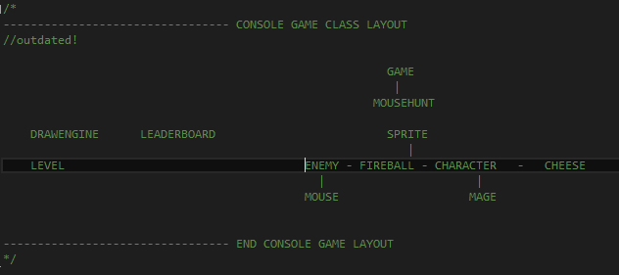

**State Diagram**

The below state diagram shows the flow of states as the end user moves through the game. As you can see there is only one state (game) that has access to the exit state, this is something I’d like to correct is development on this project was to go further.

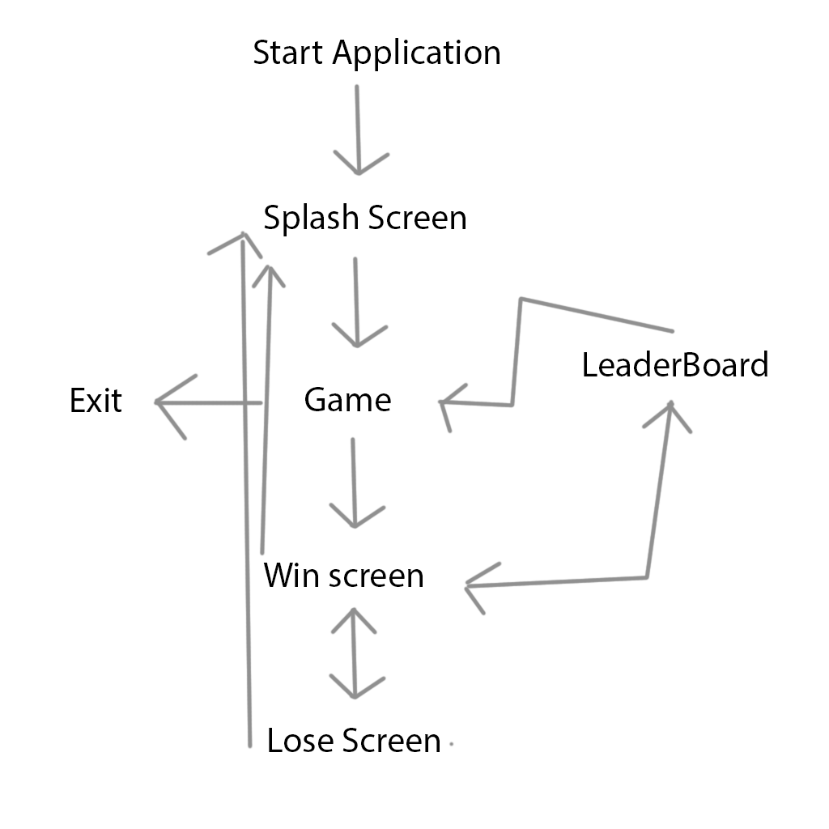

Sequence Diagram

this dequence diagram demonstrates xyz (hint what we did on the bort the other day) … (2 to 3 lines of text)

refer to image blah blah blah

**Feedback Overview and Changes**

The following feedback and changes are recommended from users playing the game.

1. Richard L
   1. Mice where to hard, I couldn't see the cheese/ tell them apart from the mice. I recommend using a 2D engine instead of ascii art.
2. Rob S
   1. Game was fairly well balanced, mice where hard to hit. I recommend taking a look at the mouse AI
3. Suzanne N
   1. I found it hard to know how many cheese and mice where left. I recommend adding a count for these to the HUD\

**File Input Output**

The following files are used in this game

1. human_readable_leaderBoard.txt (write only) - A human readable version of the leader board is generated on game end
2. leaderboard (Read/Write) - sqlite3 database

**SQLight ­ LeaderDB**

The scores are saved to the sqlight3 database.

A single table is created to contain the score. The table is formatted according to the following statement.  The create command is submitted using the Sqlite3 prepare statement. The prepare statement will return a "misuse" code if the table exists which the function then returns as a "false" value.

"CREATE TABLE leaderboard(" \

"ID INTEGER PRIMARY KEY," \

"NAME TEXT NOT NULL," \

"SCORE INT NOT NULL);";